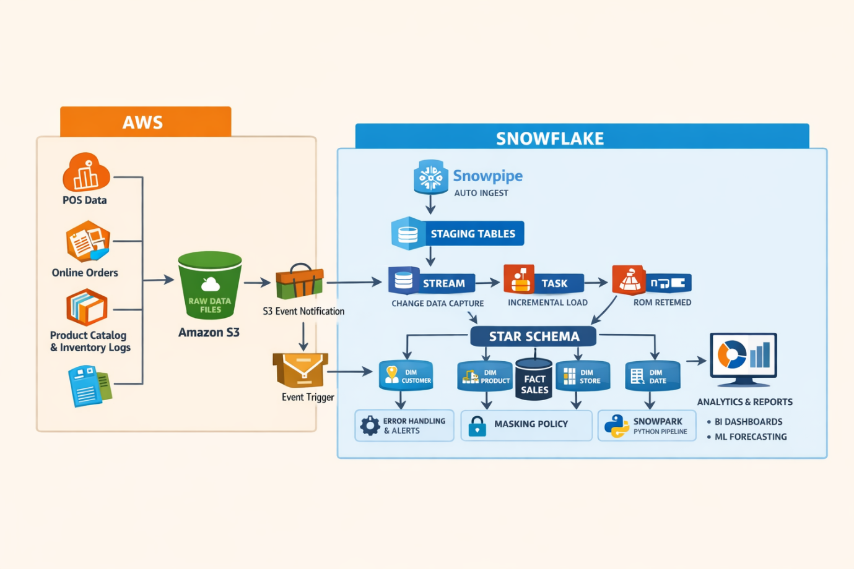
I’ve created realistic data source CSV files (1000 records each, 5 columns) and a STAR SCHEMA SQL script exactly aligned to our requirement.

Download CSV Data Sources (1000 rows each)
- POS Sales
Download pos_sales.csv
Columns
- sale_id
- customer_id
- product_id
- store_id
- sale_amount

- Online Order Feeds
Download online_orders.csv
Columns
- order_id
- customer_id
- product_id
- order_date
- order_amount

- Product Catalog Updates
Download product_catalog.csv
Columns
- product_id
- product_name
- category
- price
- status

- Inventory Device Logs
Download inventory_device_logs.csv
Columns
- device_id
- store_id
- product_id
- quantity_on_hand
- log_timestamp

STAR SCHEMA TABLES (PK & FK)
I’ve also generated a production-ready STAR SCHEMA SQL script:
Download star_schema_tables.sql
Includes:
- DIM_CUSTOMER
- DIM_PRODUCT
- DIM_STORE
- DIM_DATE
- FACT_SALES (with Foreign Keys to all dimensions)
This is Snowflake-ready and perfect for:
- Data warehouse practice
- Snowpipe / Streams / Tasks labs
- Power BI / Tableau modeling
- Interview & training demos

How the Sources Map to Star Schema
Source File | Dimension / Fact
pos_sales.csv | FACT_SALES
online_orders.csv | FACT_SALES
product_catalog.csv | DIM_PRODUCT
inventory_device_logs.csv | DIM_STORE + FACT support
dates (derived) | DIM_DATE

